MindTrack Project

Application Deployment
(Deploy the given React application to a production ready state)

Application:
Clone the below mentioned repository and deploy the application (Run application in port 3000).
Repo URL : https://github.com/Vennilavanguvi/Brain-Tasks-App.git

Launch EC2 Instance
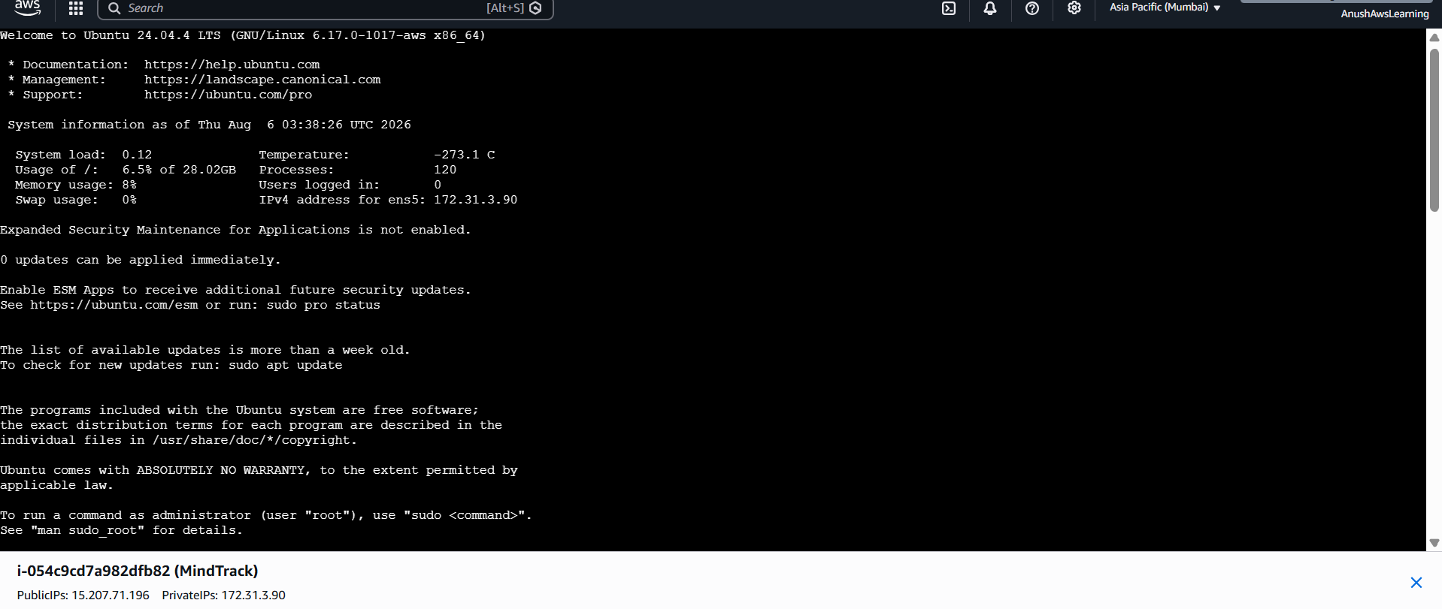
Install Required Tool
Git
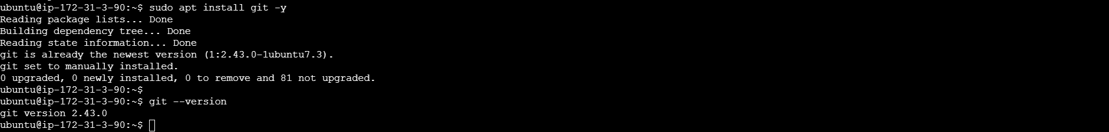
Create Project Folder
Clone Repository
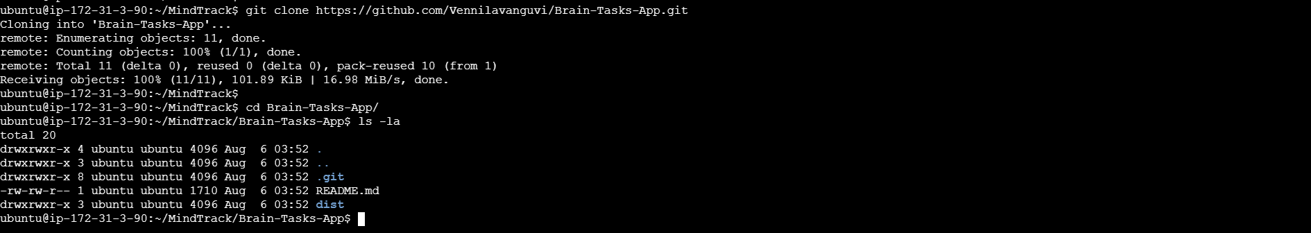
Docker:
- Dockerize the application by creating Dockerfile
Install Docker
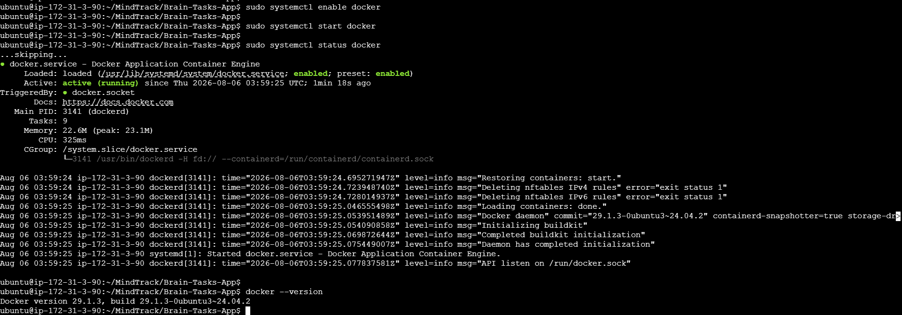
Allow Ubuntu User to Run Docker
Create Dockerfile
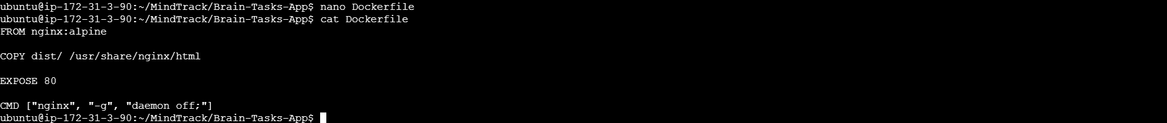

- Build an application and check output using docker image.
Build the Docker Image
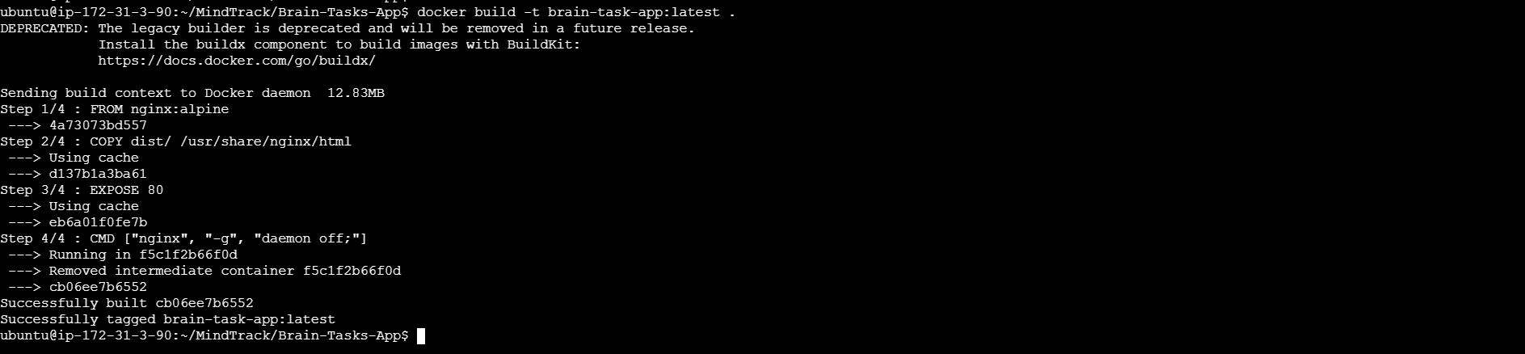
Verify the Docker Image
Run the Container and Verify
Test from the EC2 Server
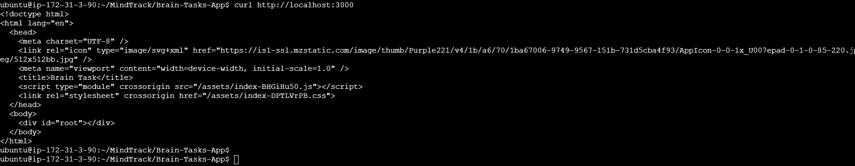
Test in the Browser
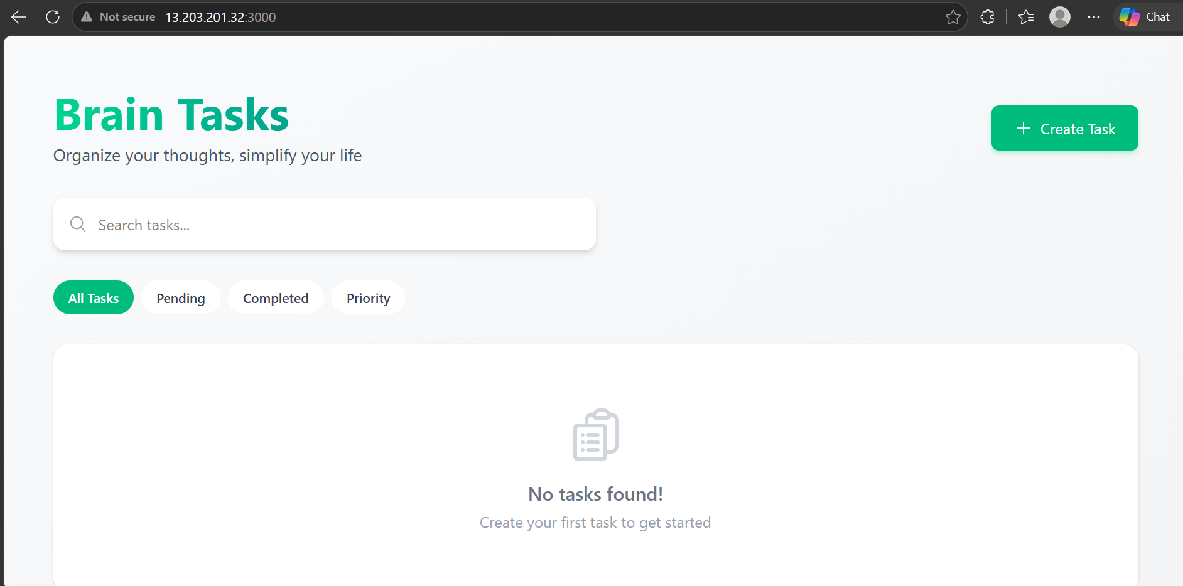

Registry:
- Create an AWS ECR or Dockerhub repository for storing docker images.
AWS CLI Installation
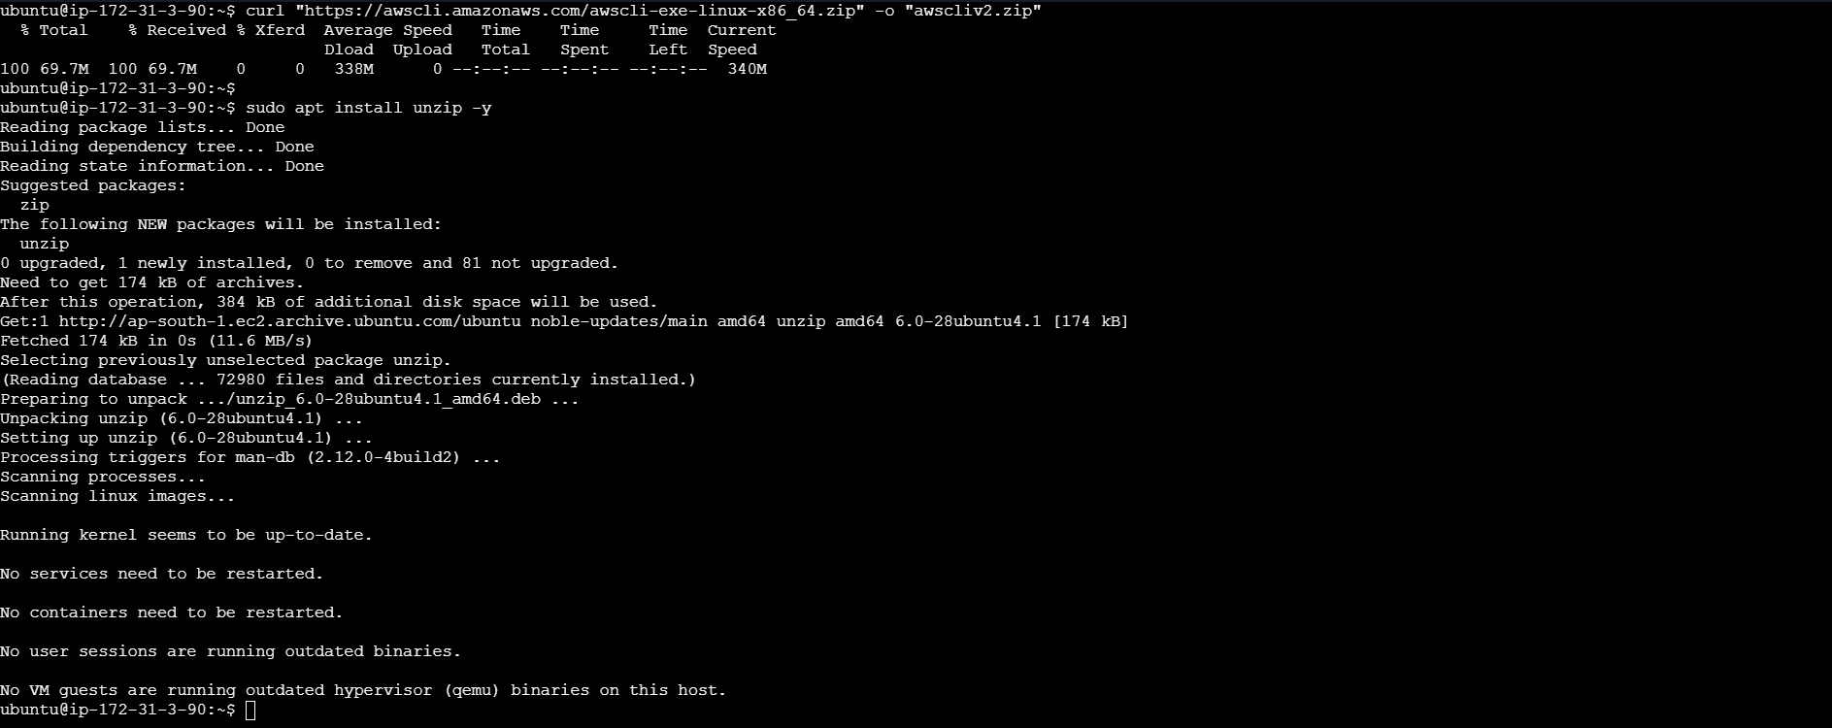
Verify AWS CLI Configuration
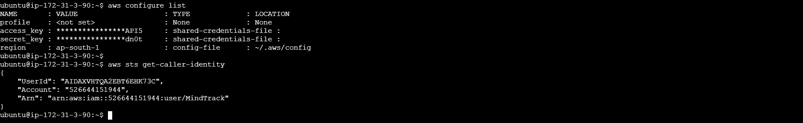
Create an Amazon ECR Repository
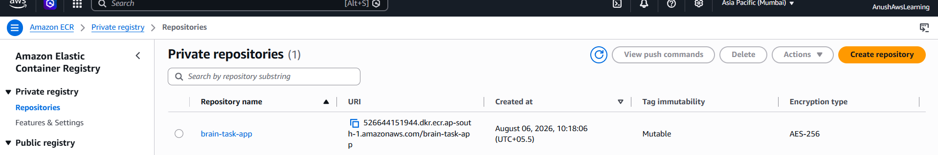
Login to Amazon ECR
Verify and Tag the Local Docker Image
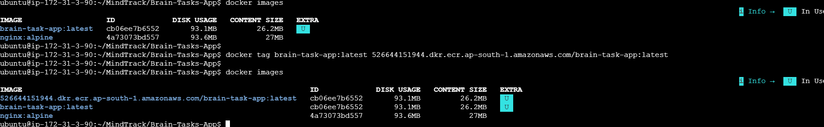
Push the Docker Image to Amazon ECR
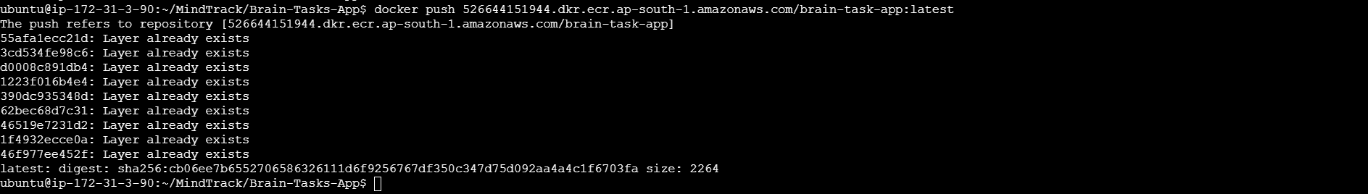
Verify the Image in Amazon ECR
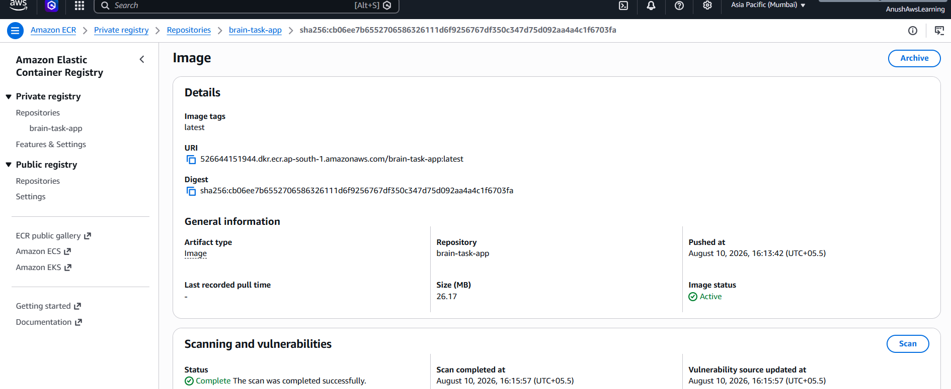
Test the Pulled Docker Image
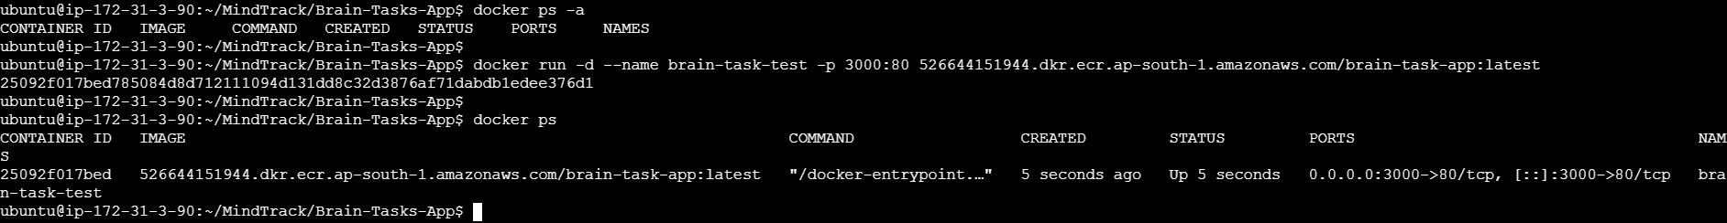
Test the Application in the Browser Using Public IP
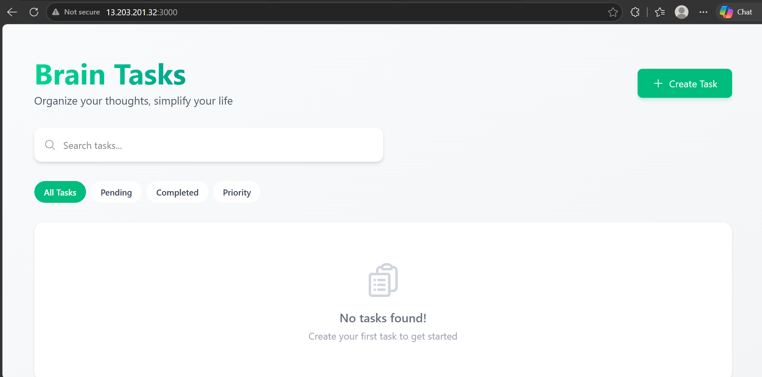

Kubernetes:
- Setup Kubernetes in AWS EKS and Confirm EKS cluster is running.
Install Required Tools
kubectl
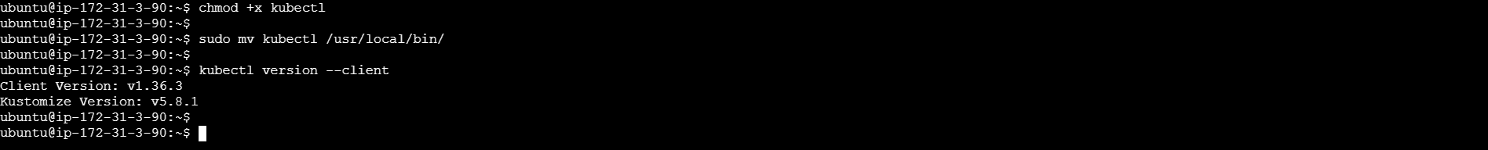
eksctl
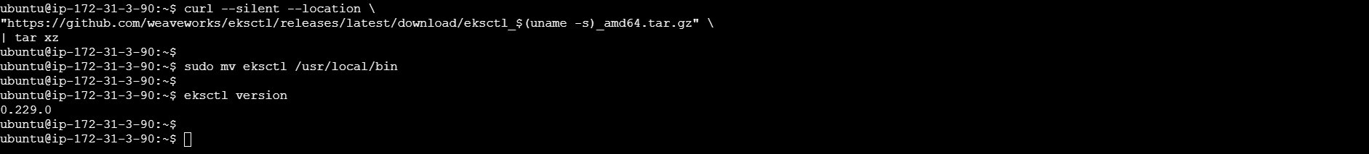
Create the Amazon EKS Cluster
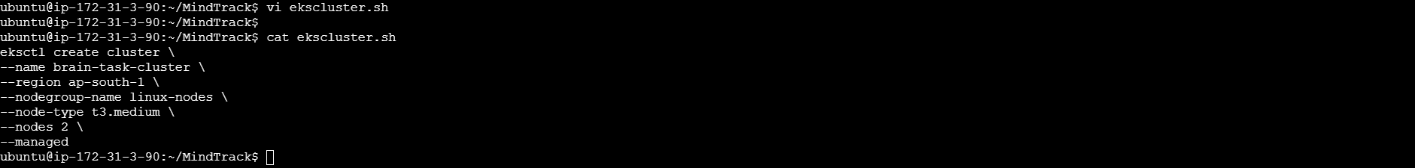
Execute the EKS Cluster creation script
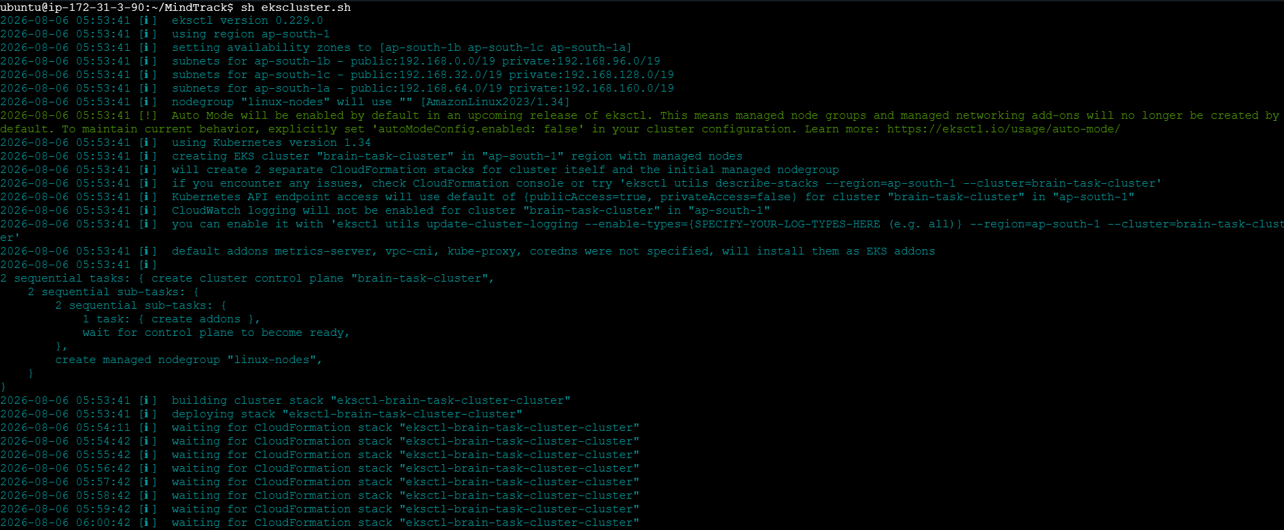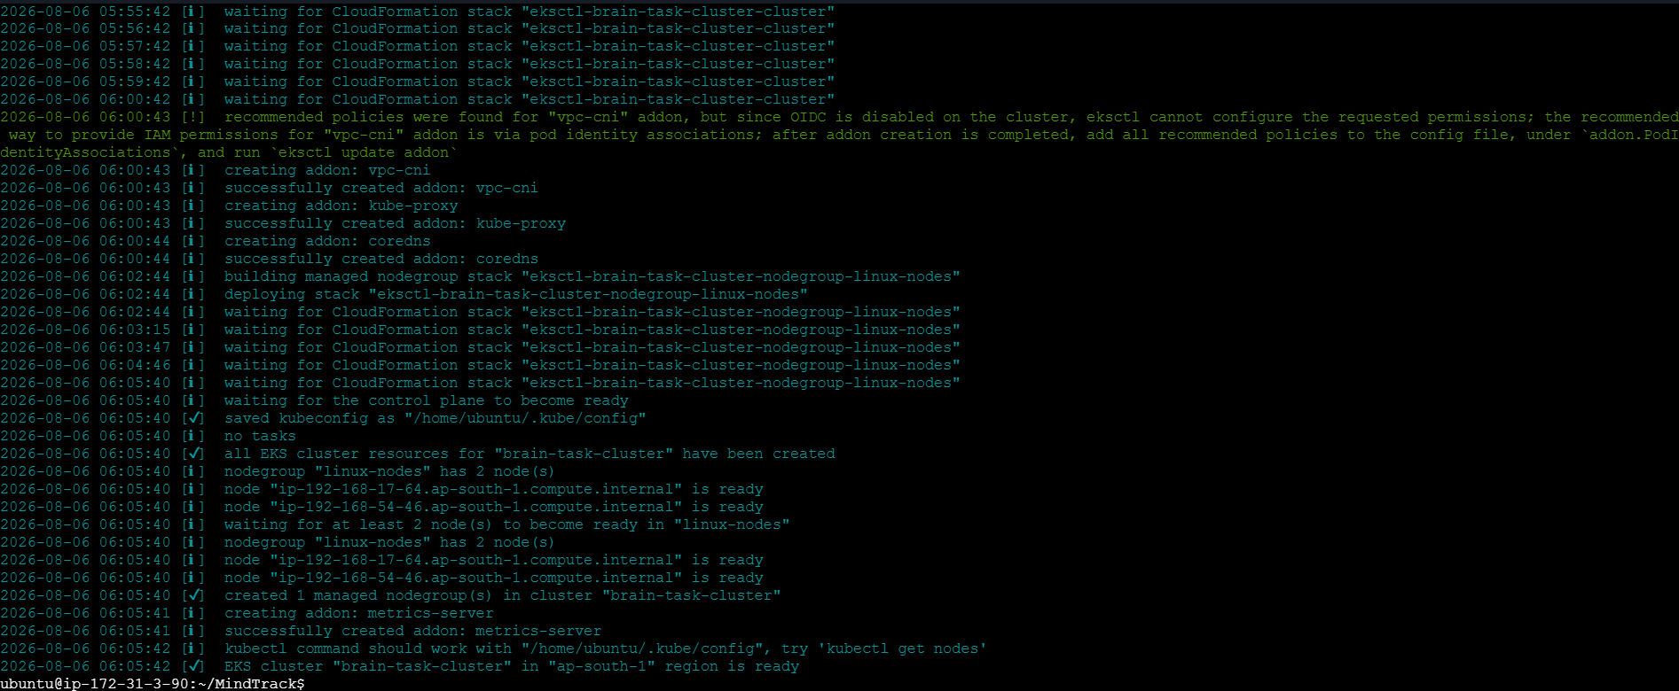
Update kubeconfig
Verify the Created Cluster
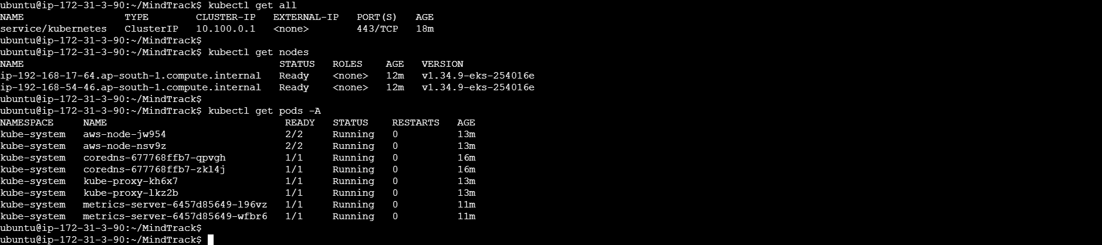

- Write deployment and service YAML files.
Create Deployment YAML
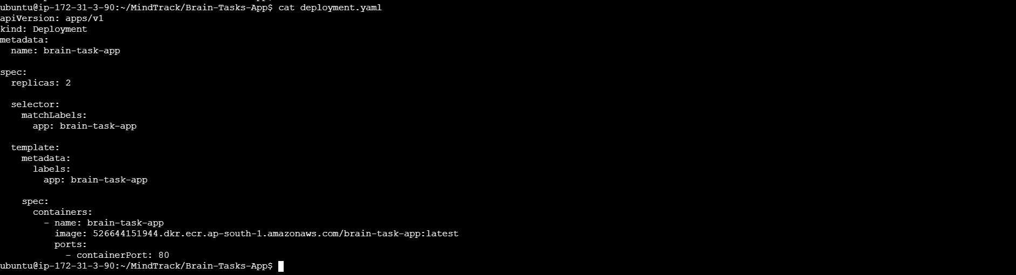
Create Service YAML
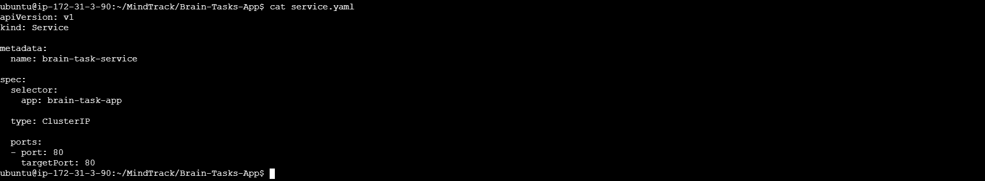
Create Ingress YAML
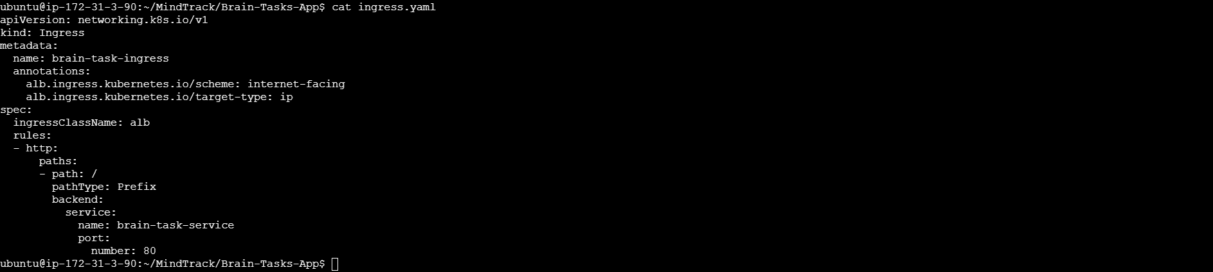
Deploy to Amazon EKS
Verify Deployment
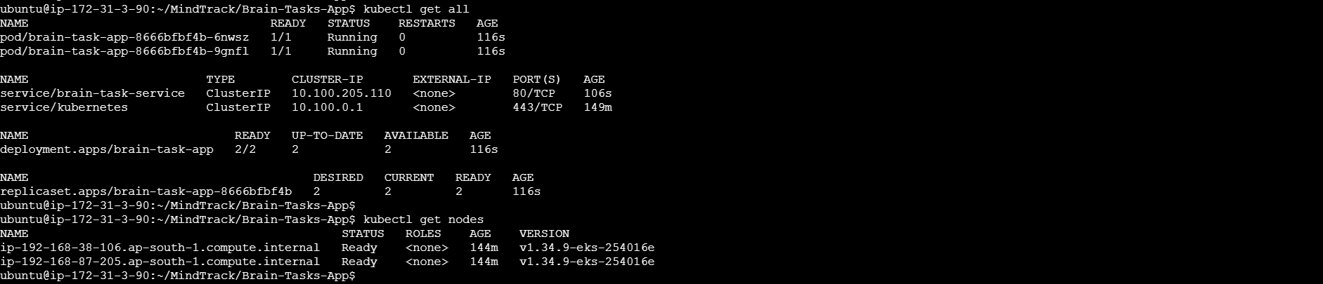
Check the application through AWS Load Balancer URL
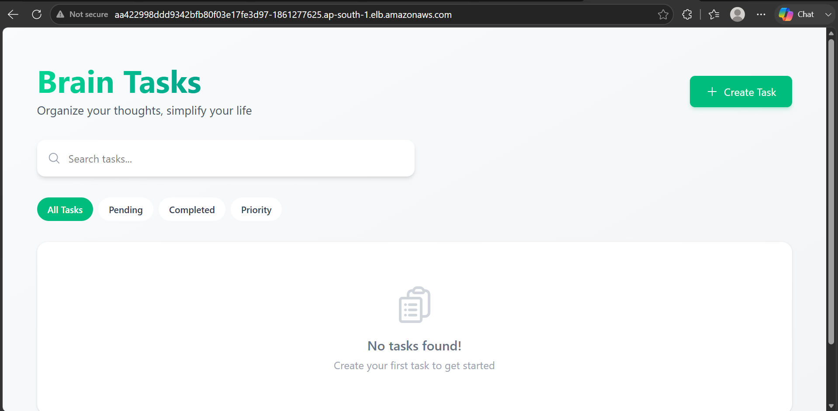
Version Control:
- Push the codebase to a Git provider (GitHub).
Project Files in Local Server
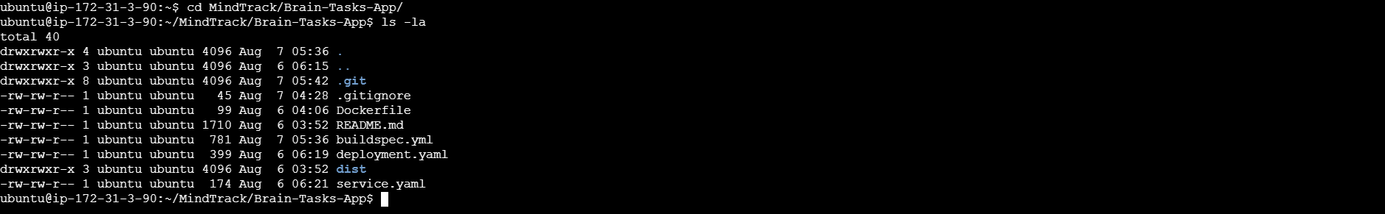
Git Tool Check
Create a GitHub Repository
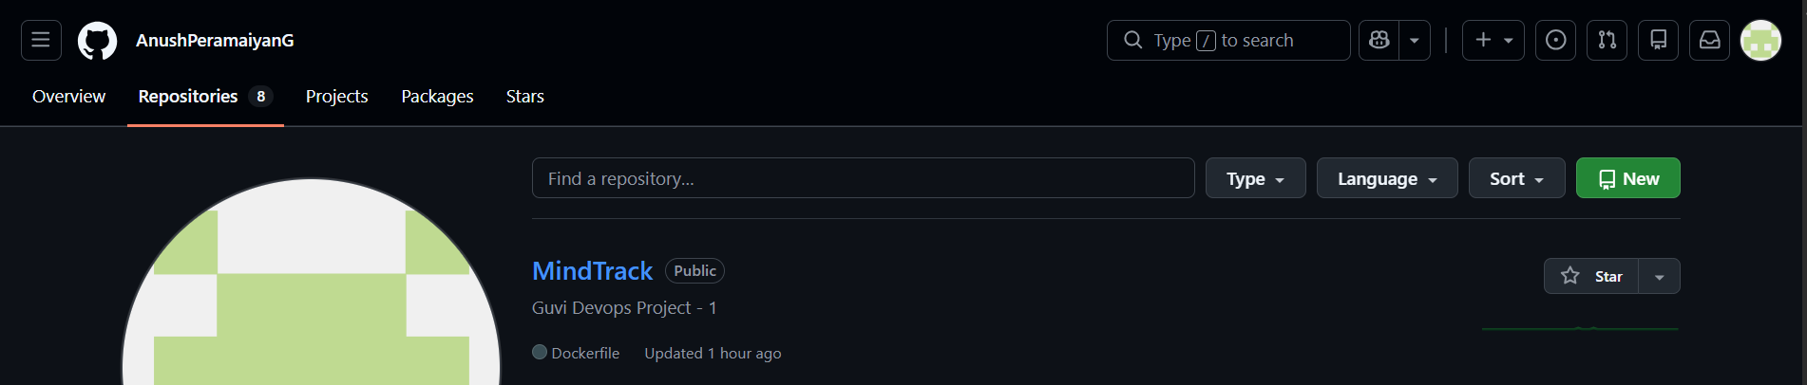

- Use CLI commands to push code.
Initialize Git
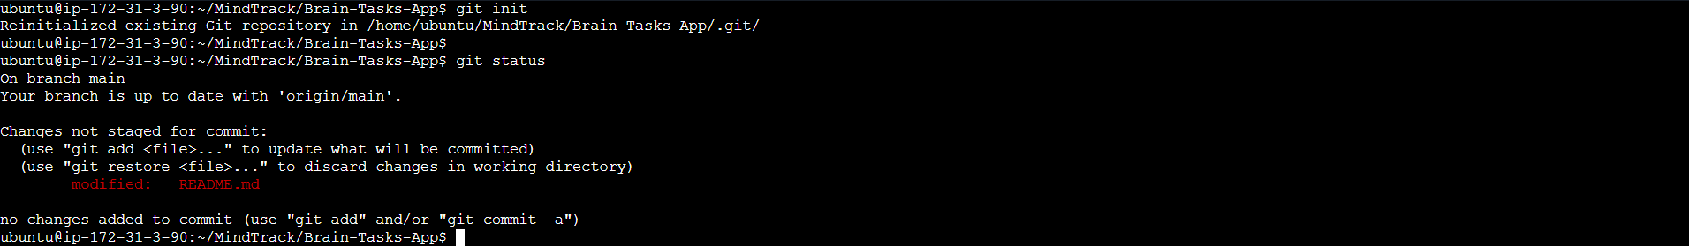
Stage the Files
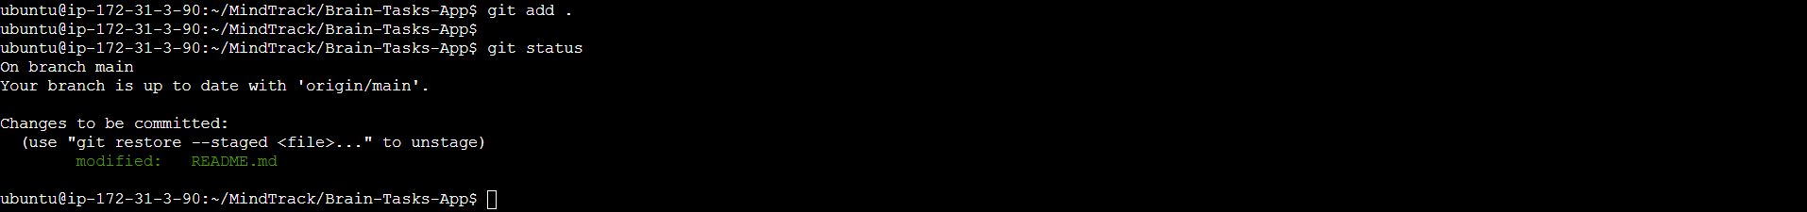
Commit the Changes
Add the Remote Repository
Push the Code
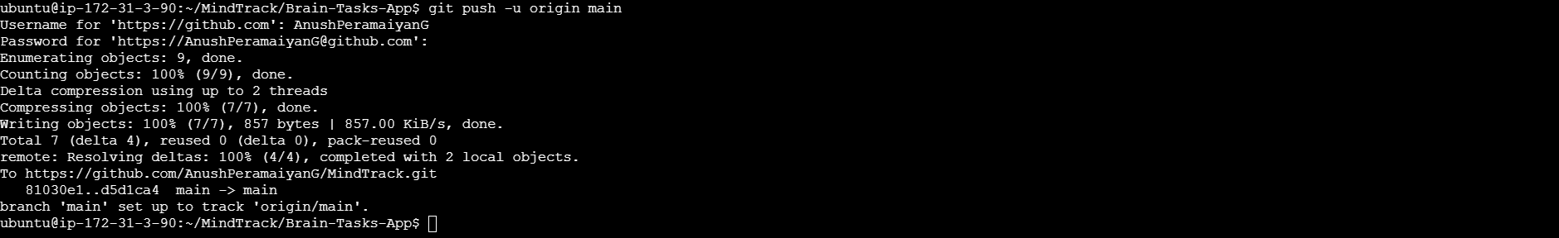
Verify on GitHub
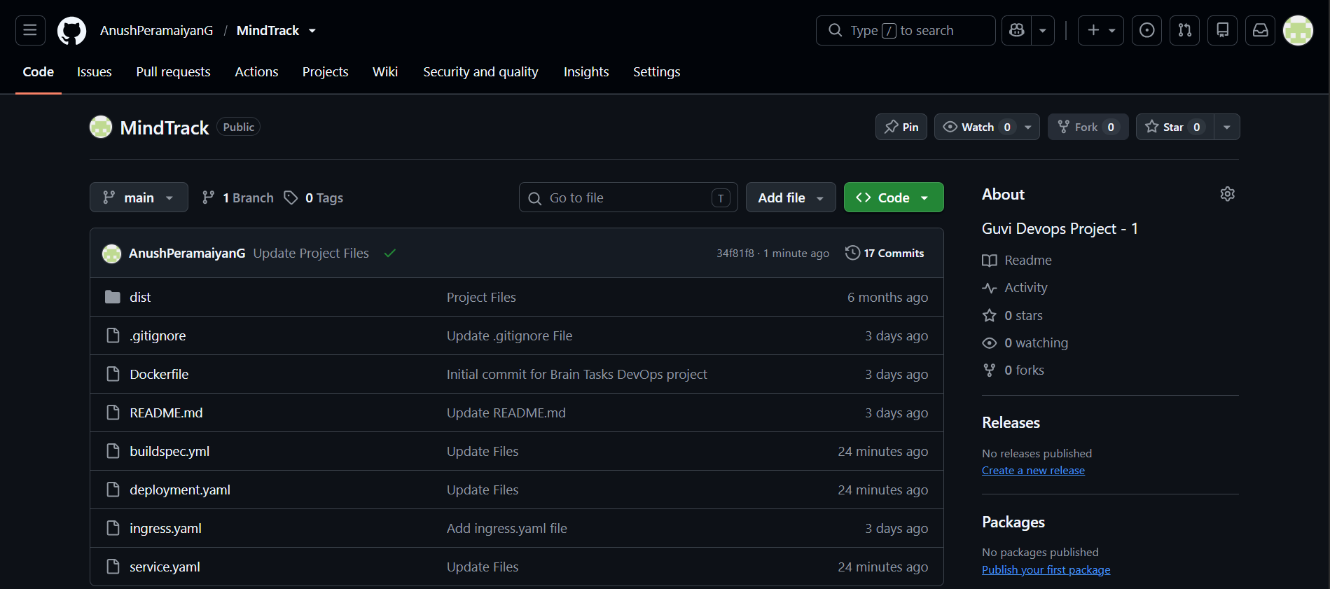

CodeBuild:
Create an IAM Role for CodeBuild
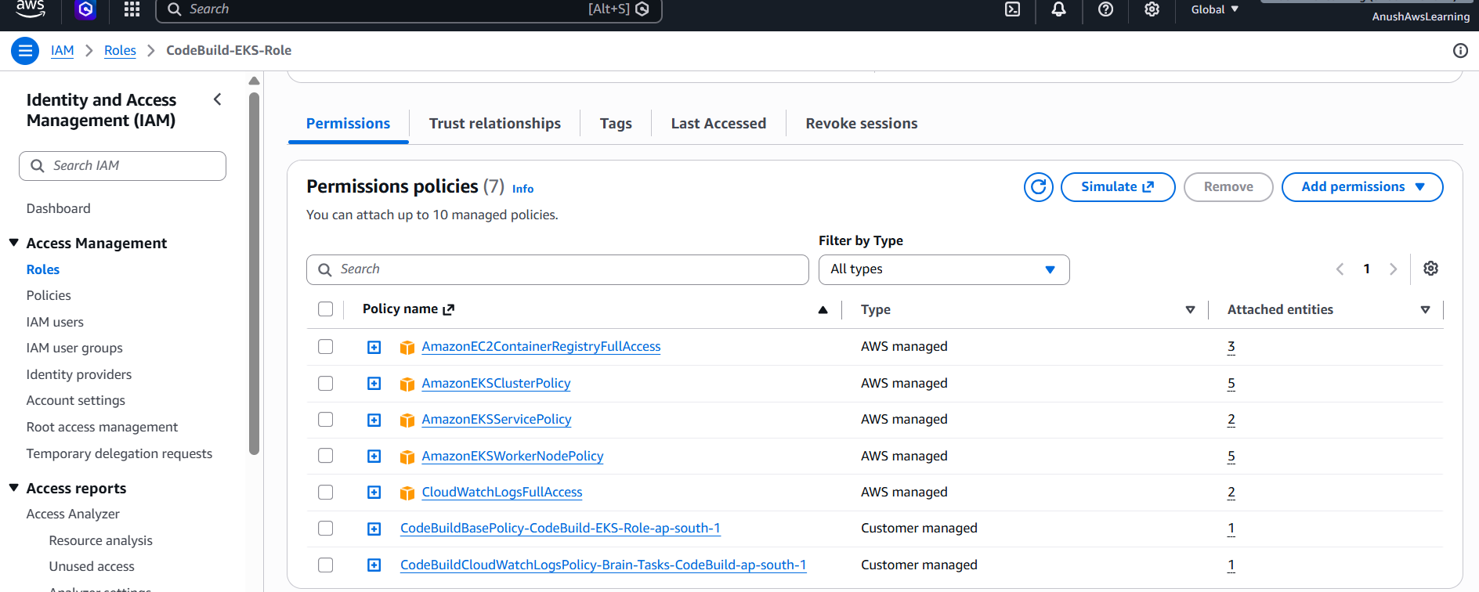

- Create a CodeBuild project:
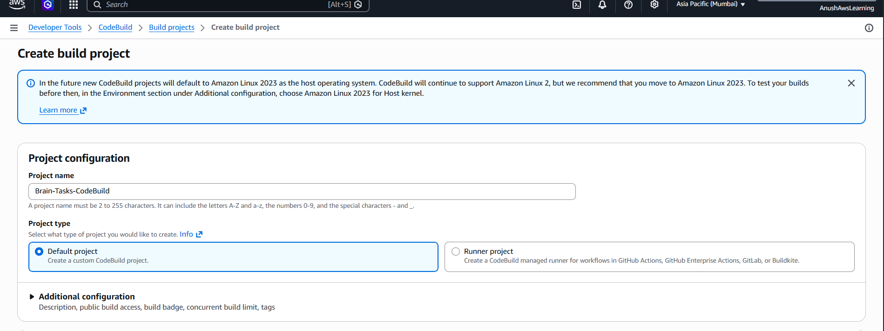
- Source: Connect to your repository
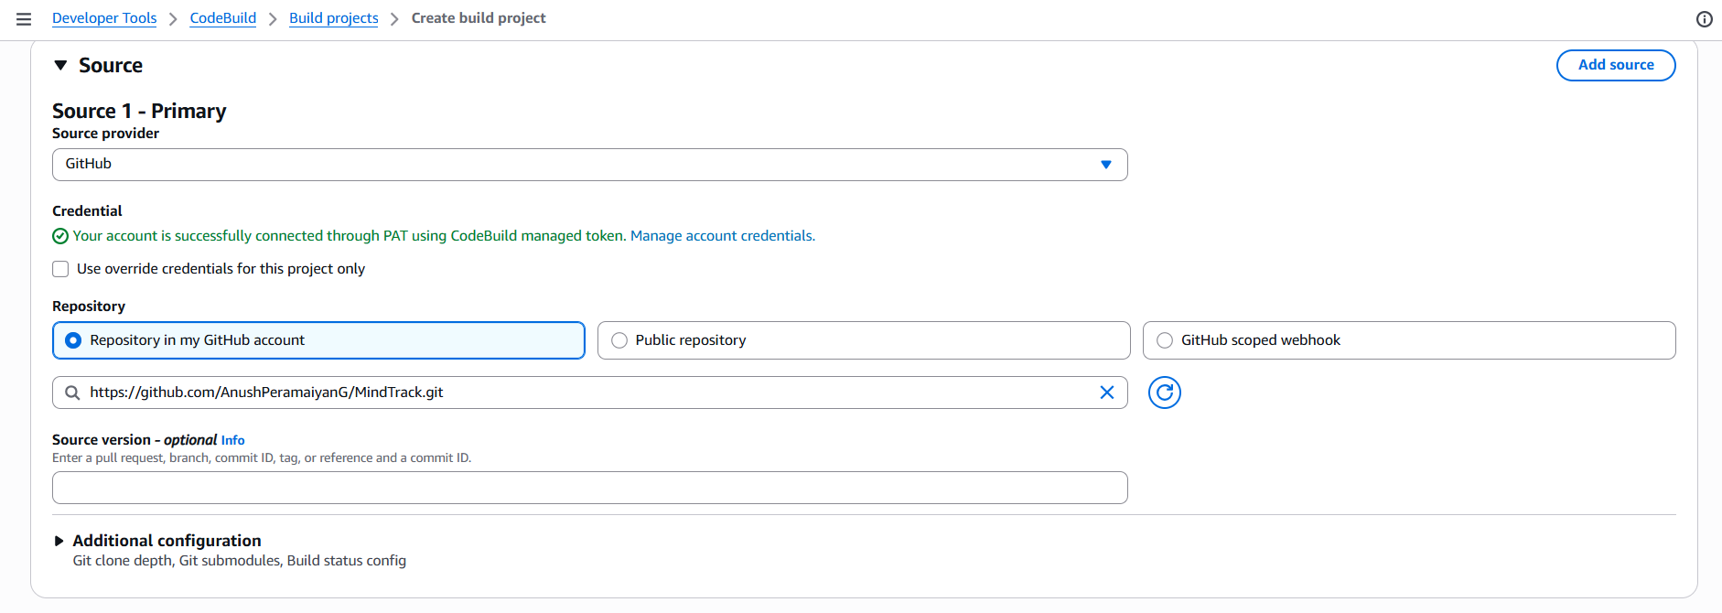
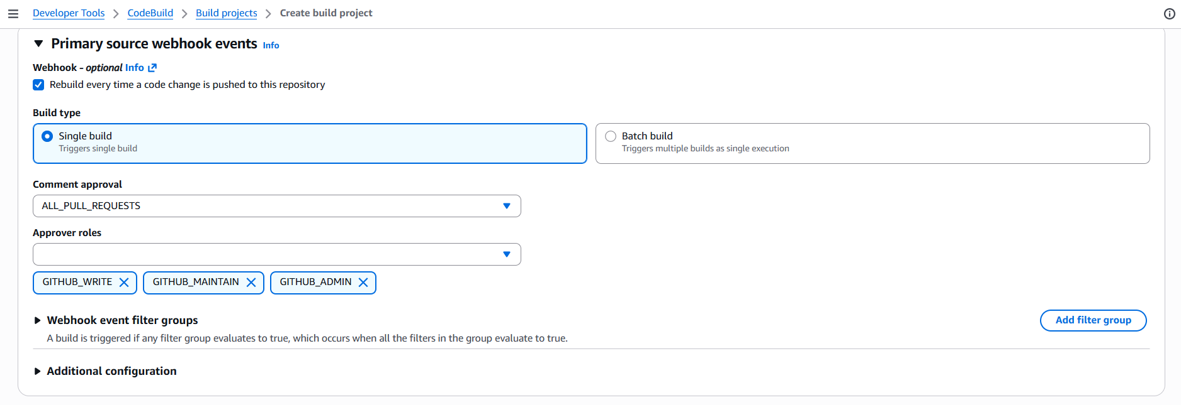
- Environment: Use managed image (Amazon Linux, Ubuntu)
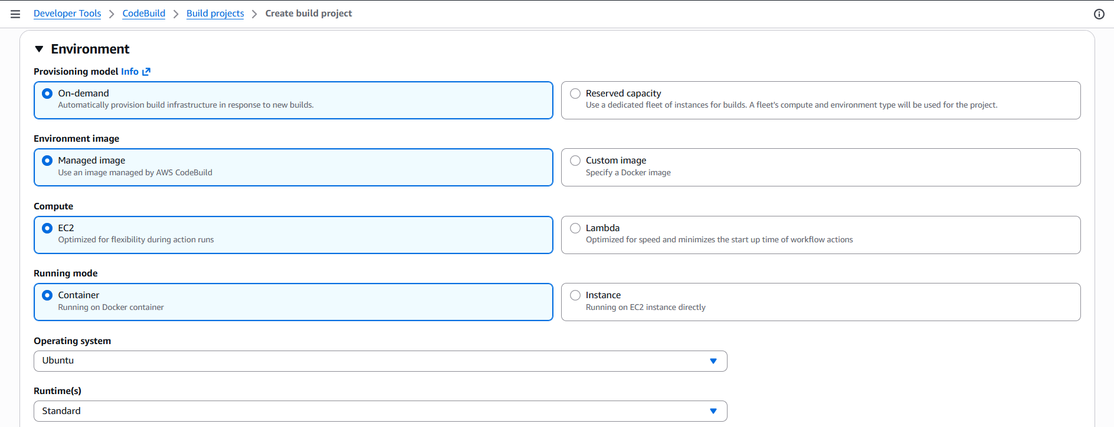
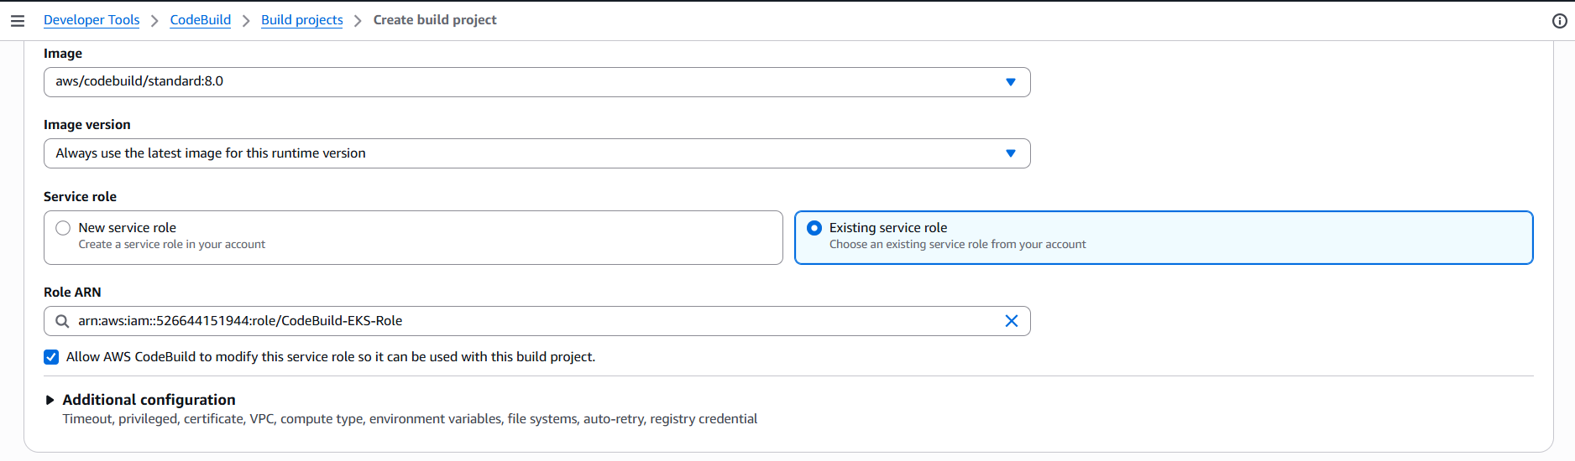
- Write and define commands in buildspec.yml.
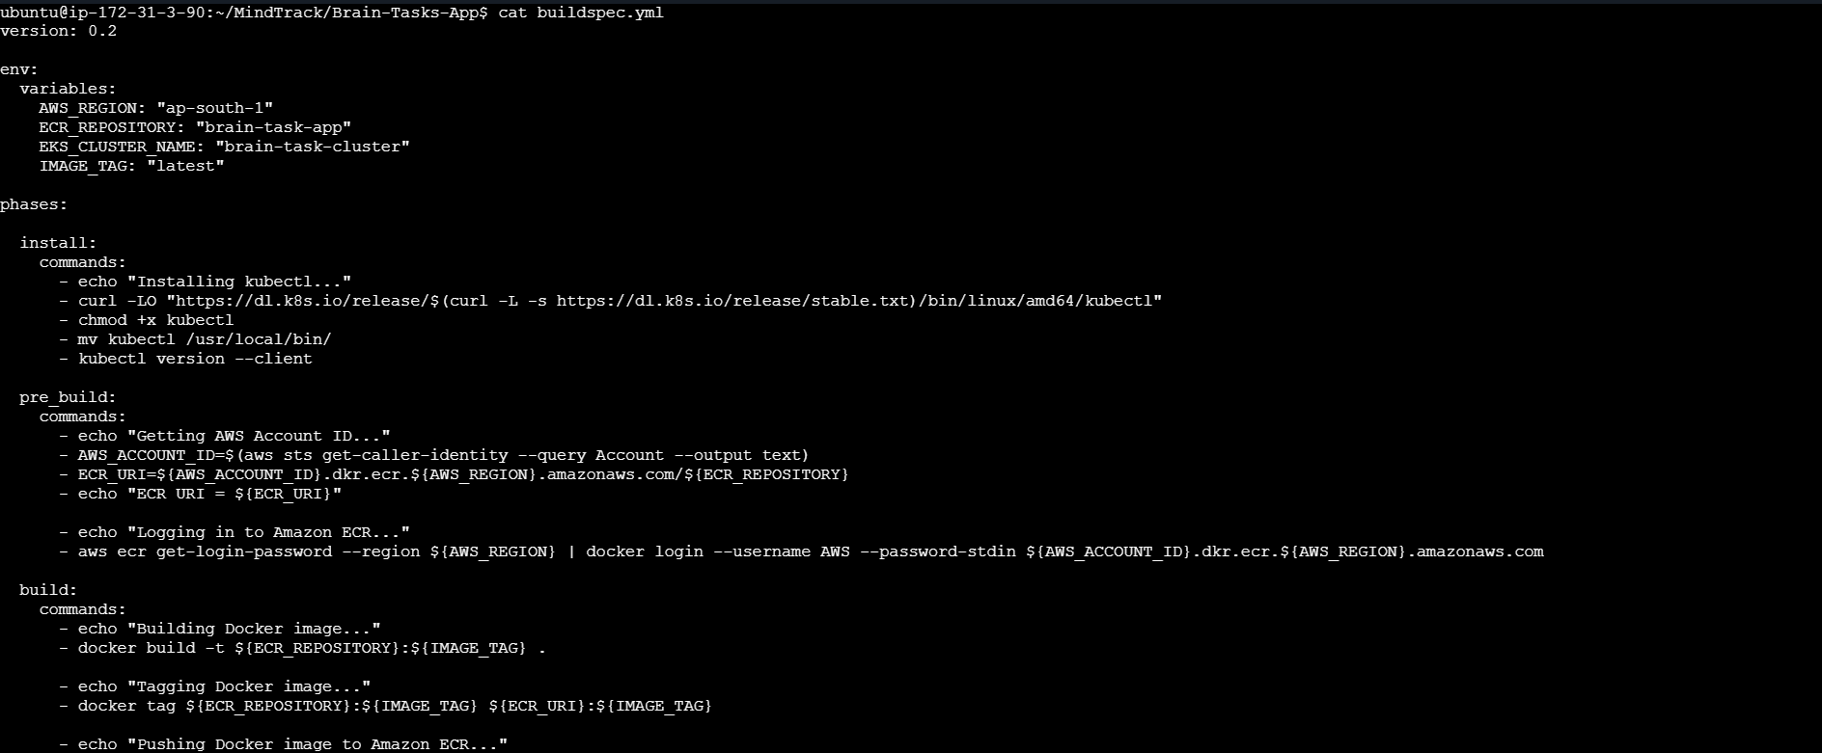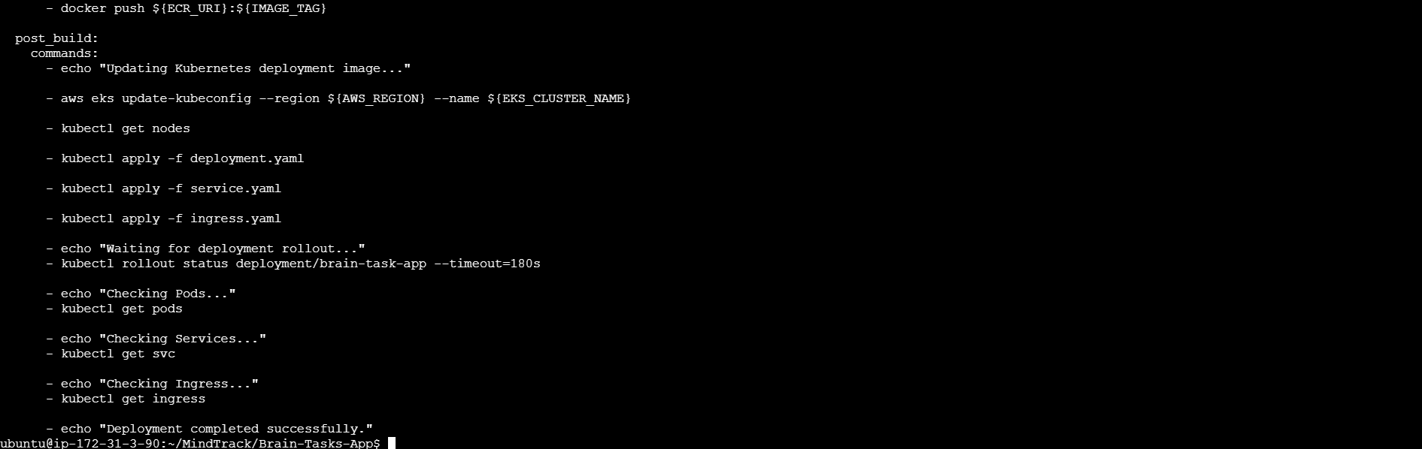
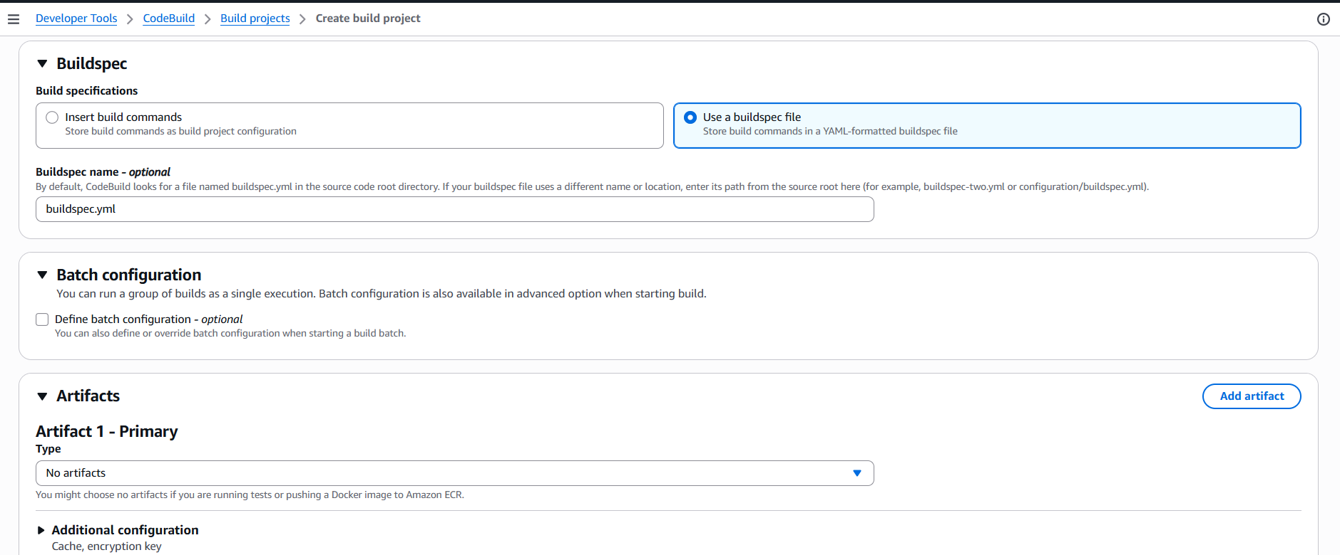
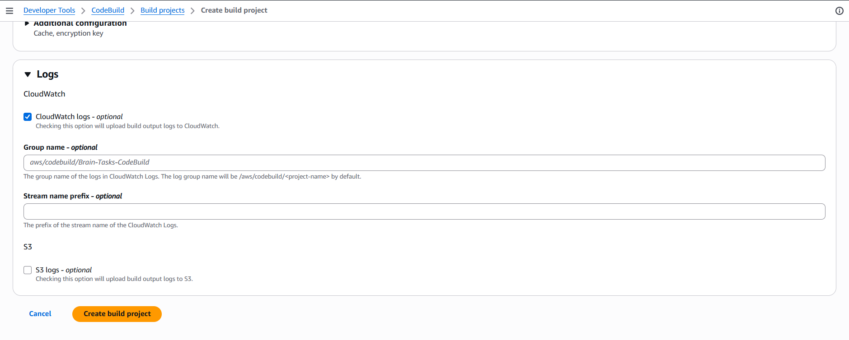

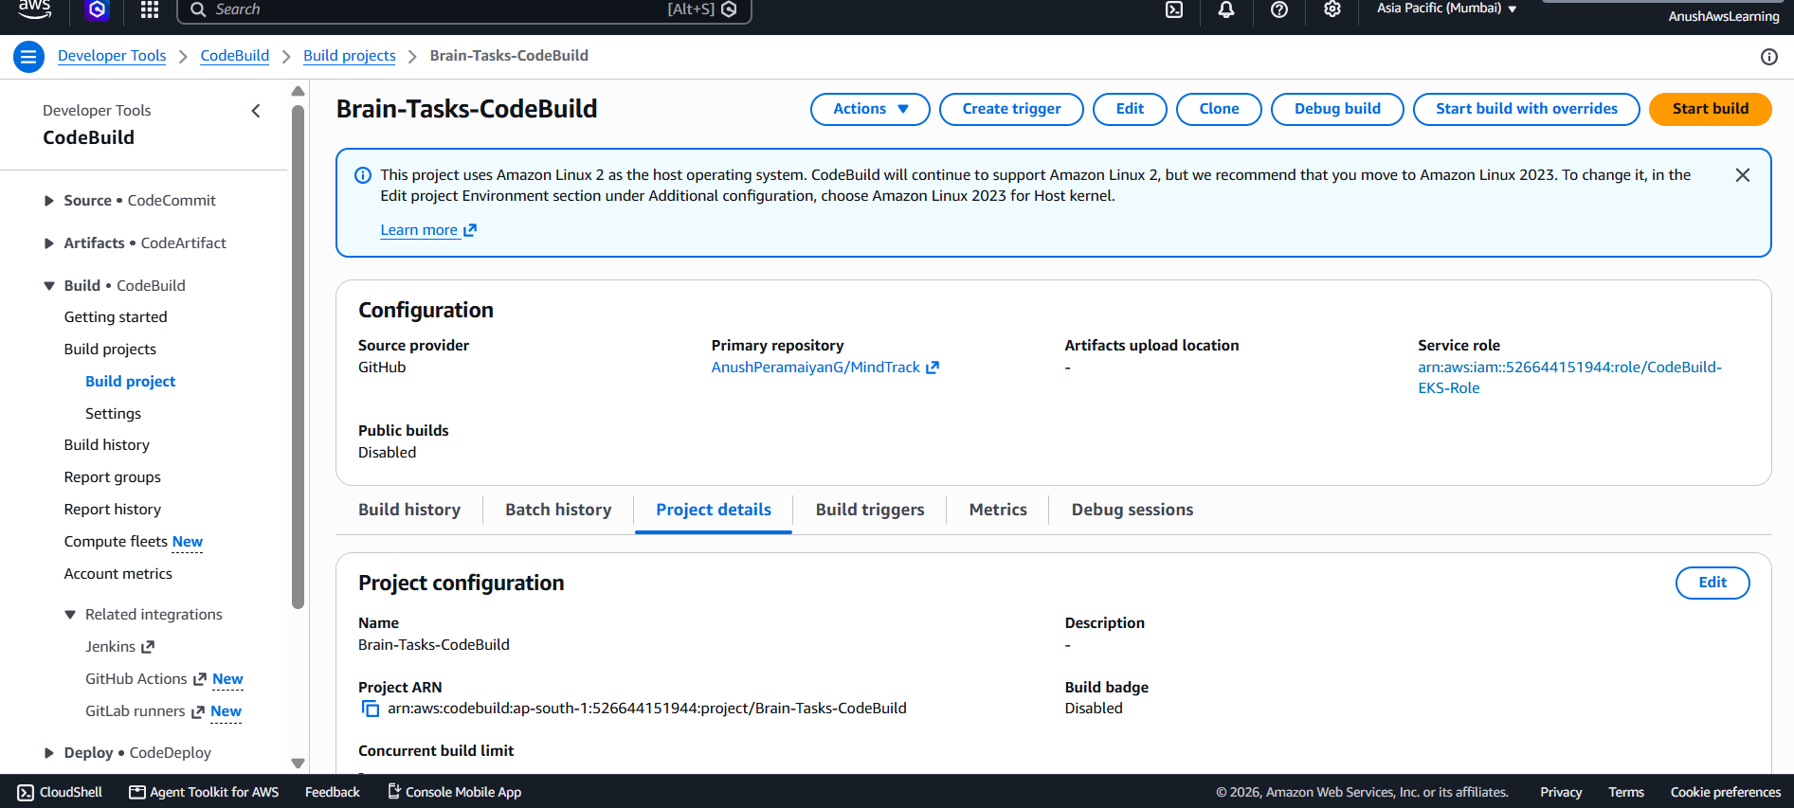

Test CodeBuild
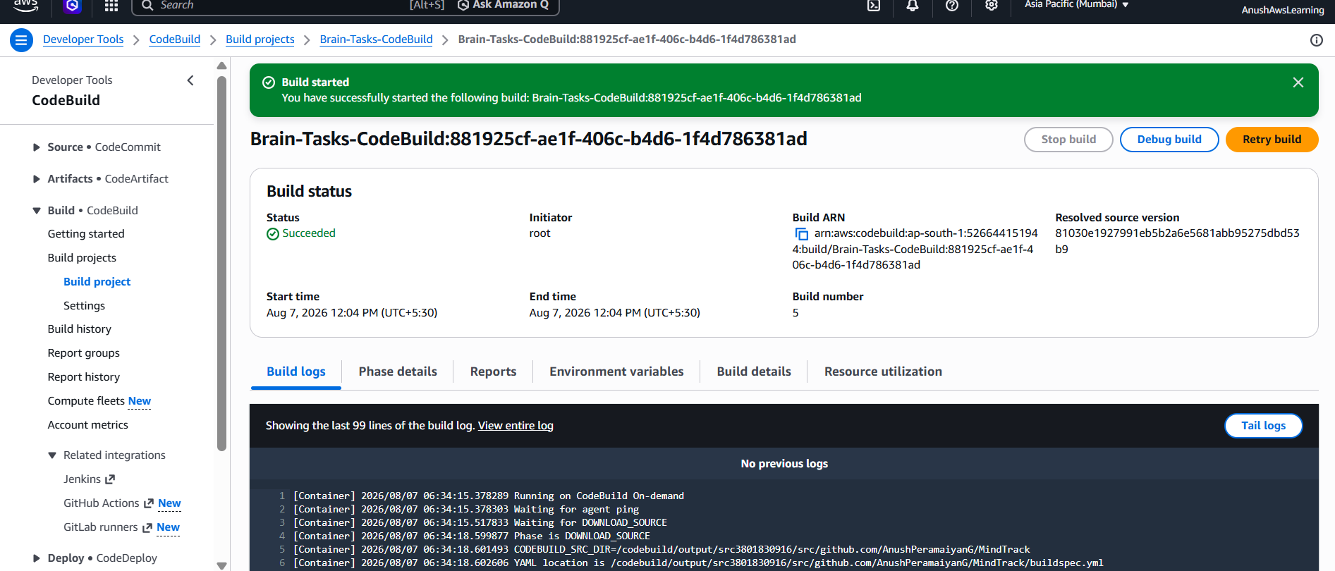

Check Build Phase Status
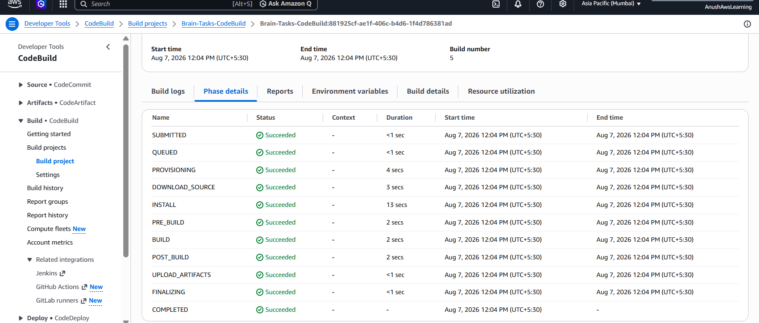
Verify the EKS Deployment
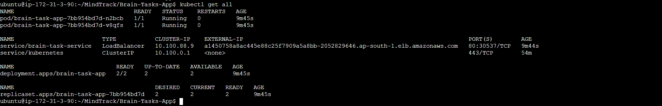
Test the application through AWS Load Balancer URL
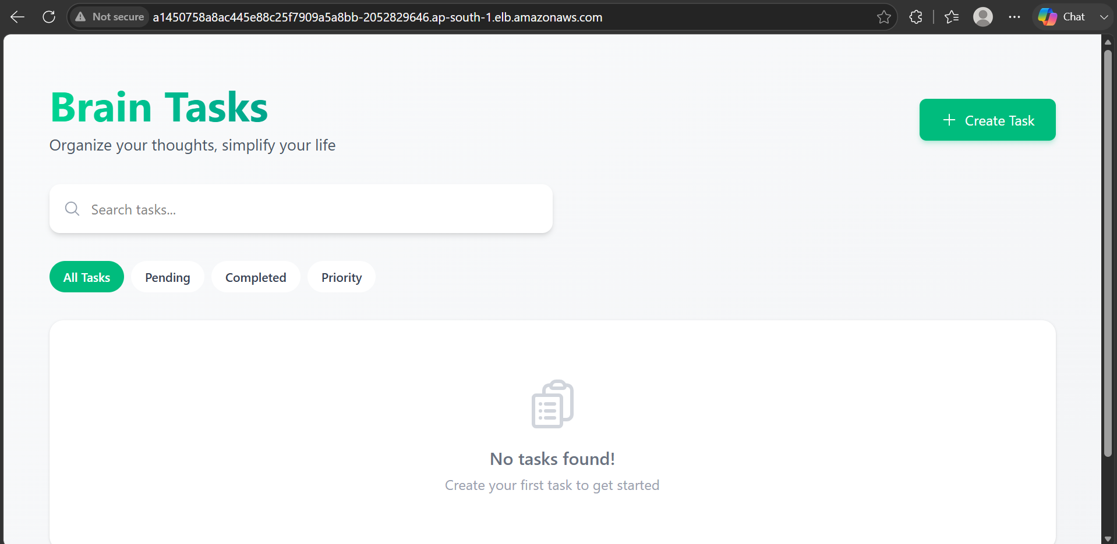

CodePipeline:
- Source: GitHub
- Build: AWS CodeBuild project
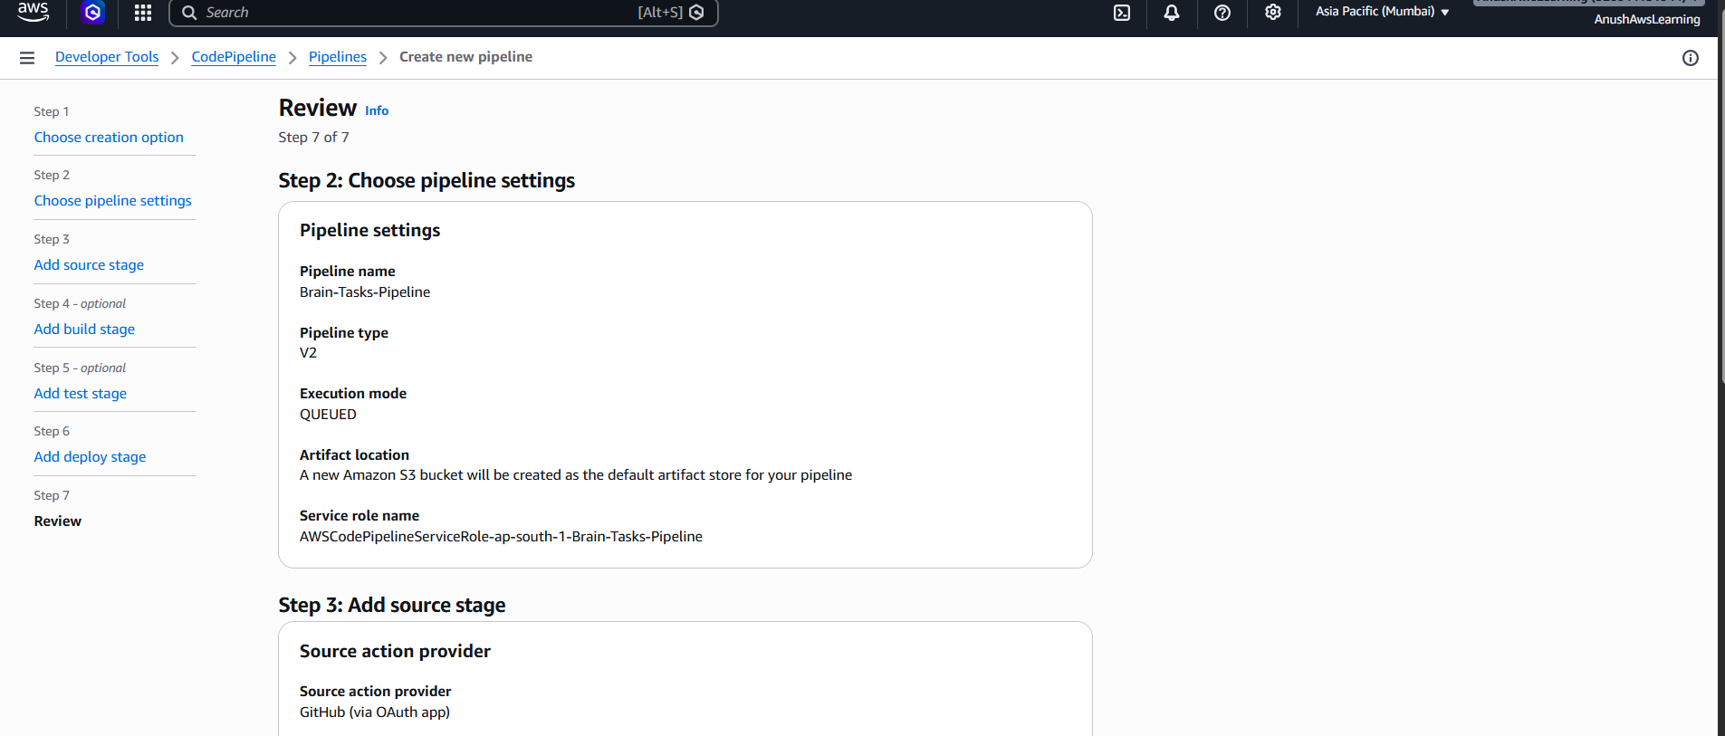
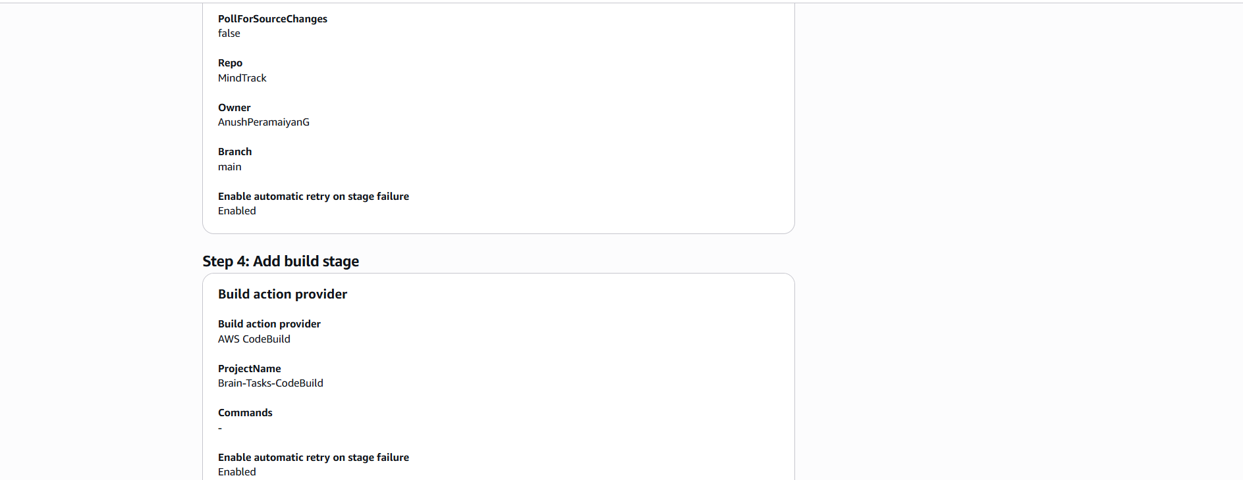

- Deploy: Deploy to EKS via Codepipeline EKS deploy stage.

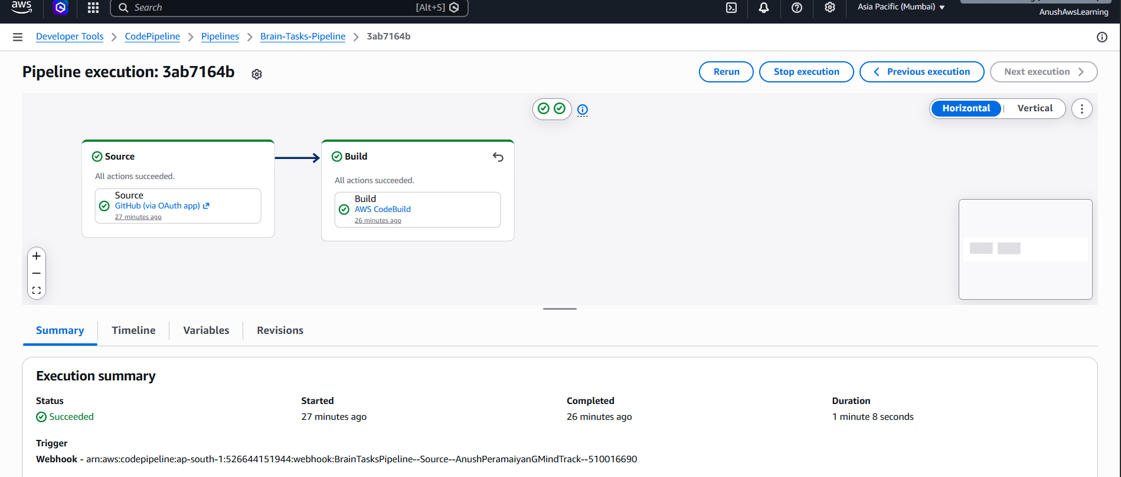
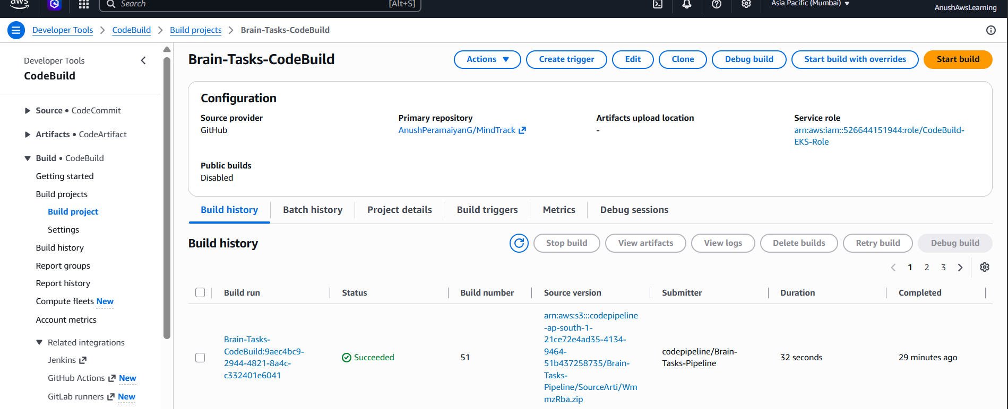
Verify the EKS Deployment
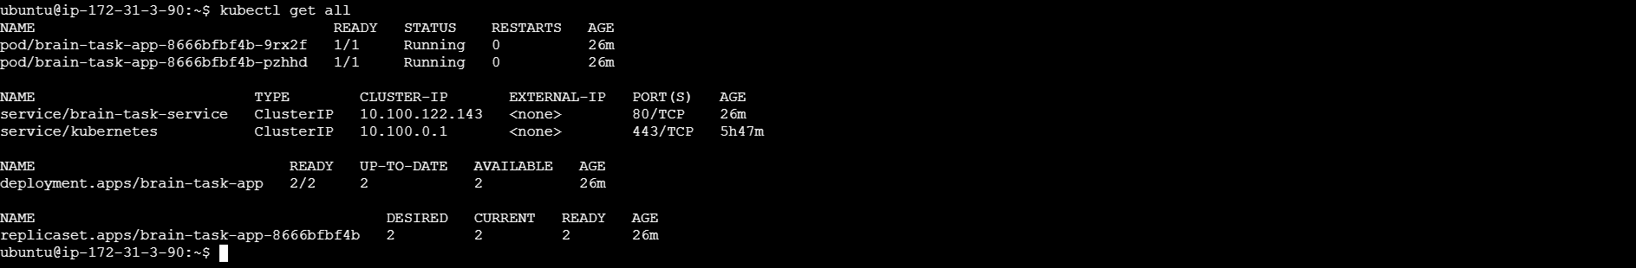
Test the application through AWS Load Balancer URL
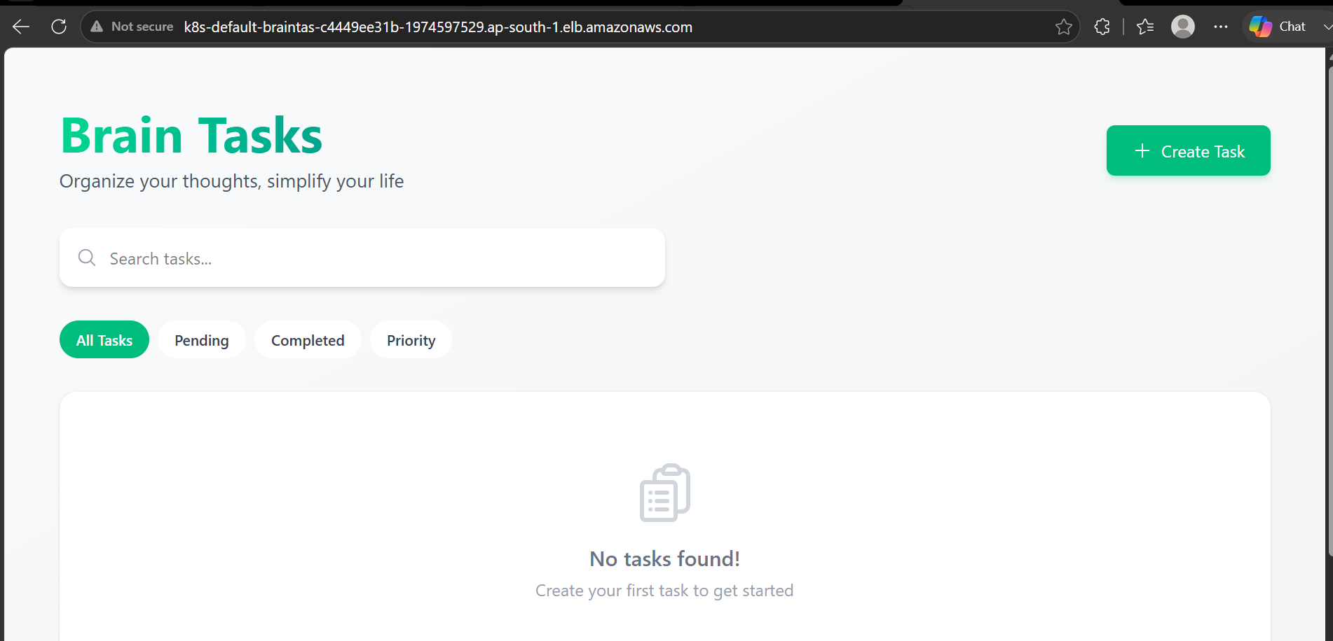
ALB created in AWS as below:
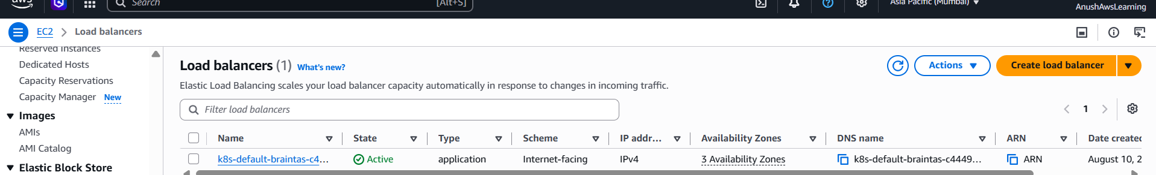

Monitoring:
- Use CloudWatch Logs to track build, deploy, and application logs.

Enable CloudWatch Logs for CodeBuild
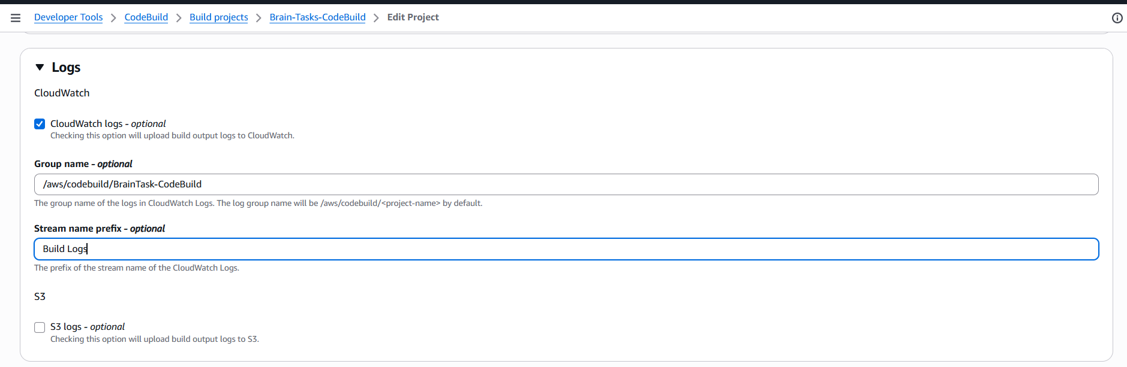
Verify CodeBuild Logging
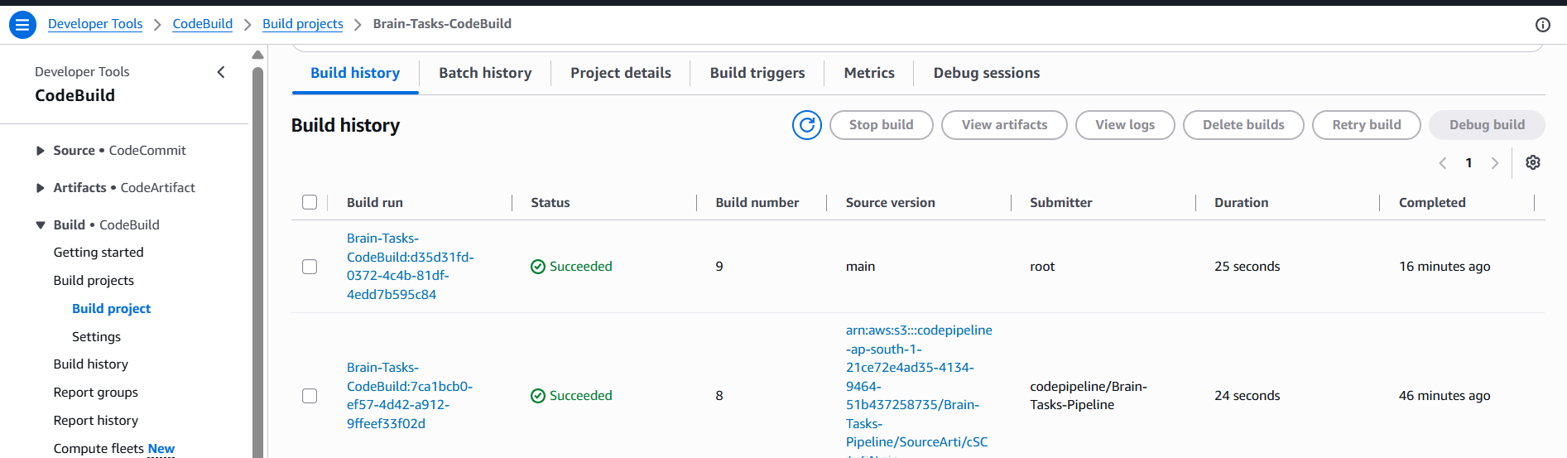

Check CloudWatch Logs on CodeBuild
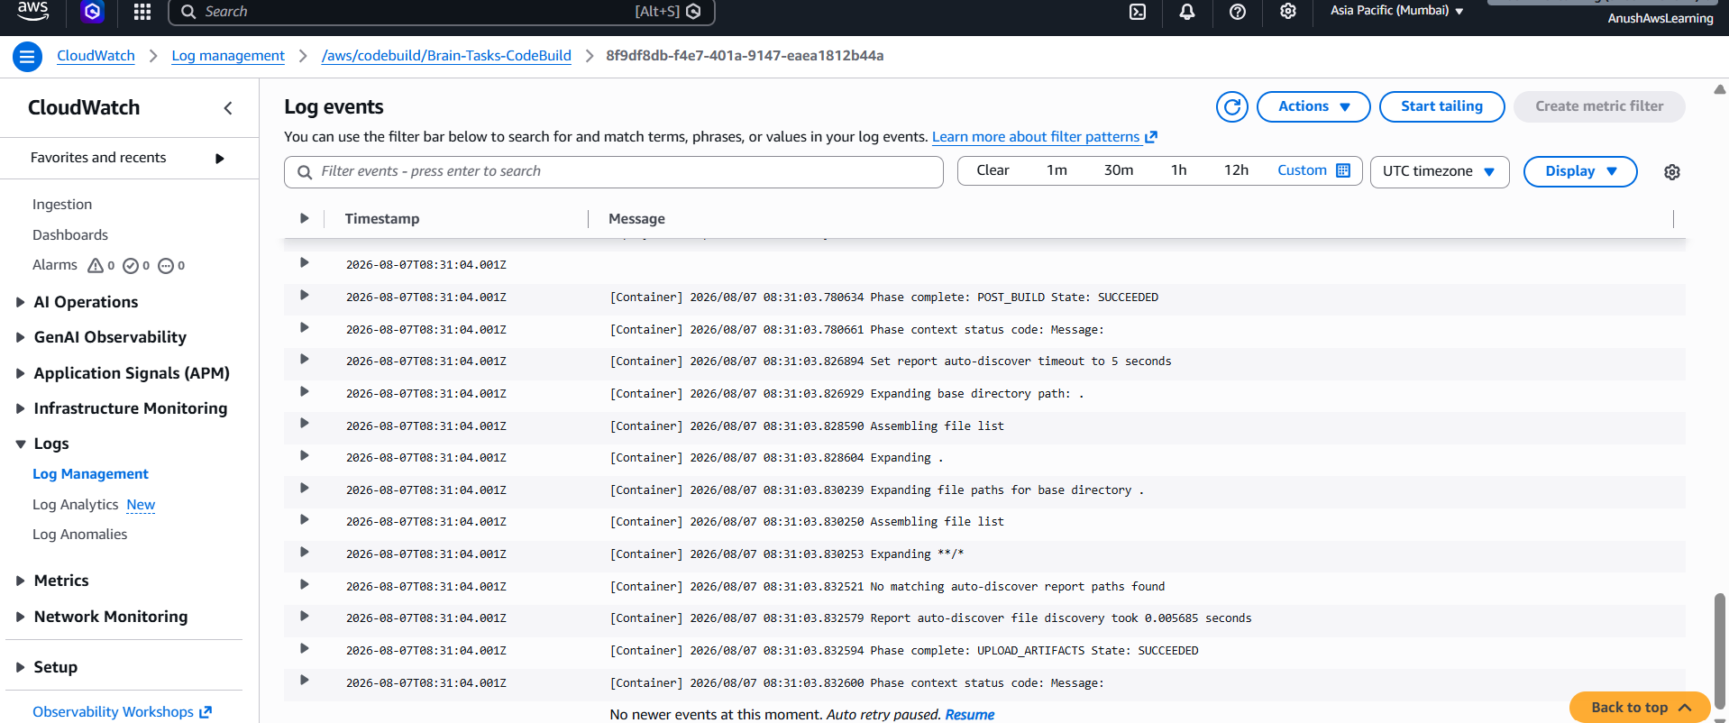

Monitor CodePipeline
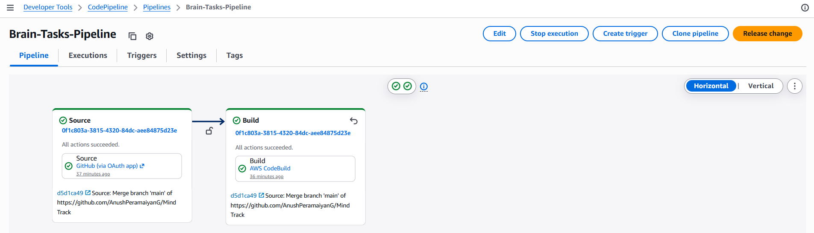
Verify Kubernetes Application
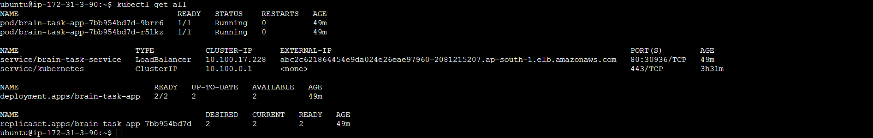
View Application Logs
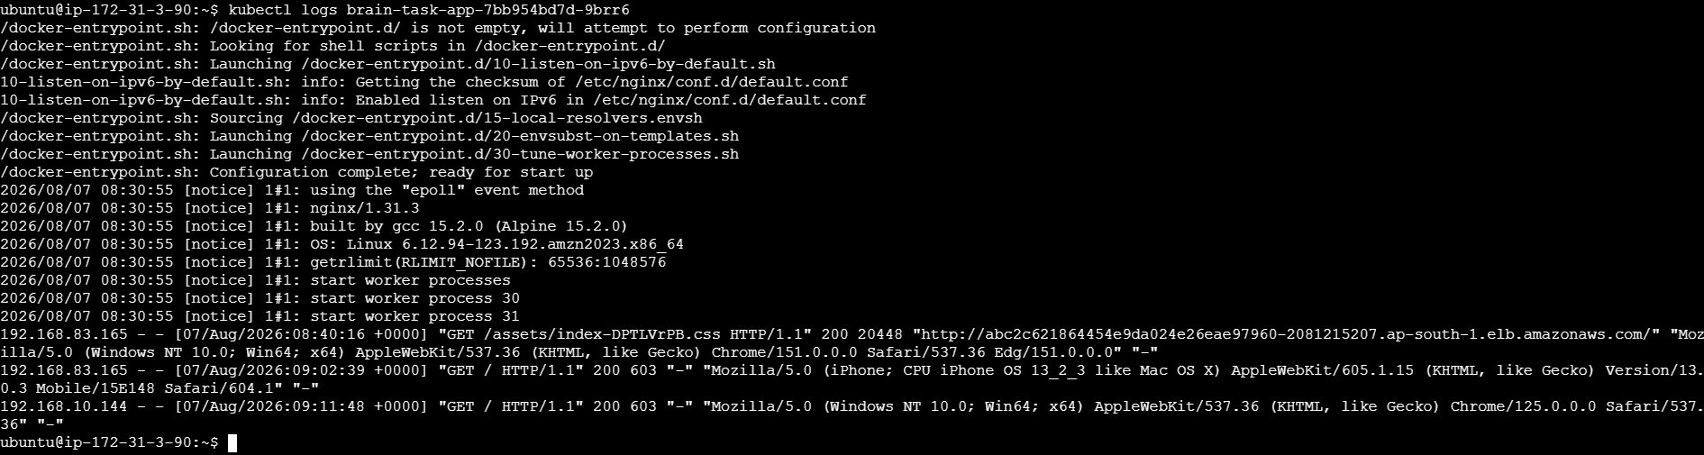

Verify CloudWatch Log Groups
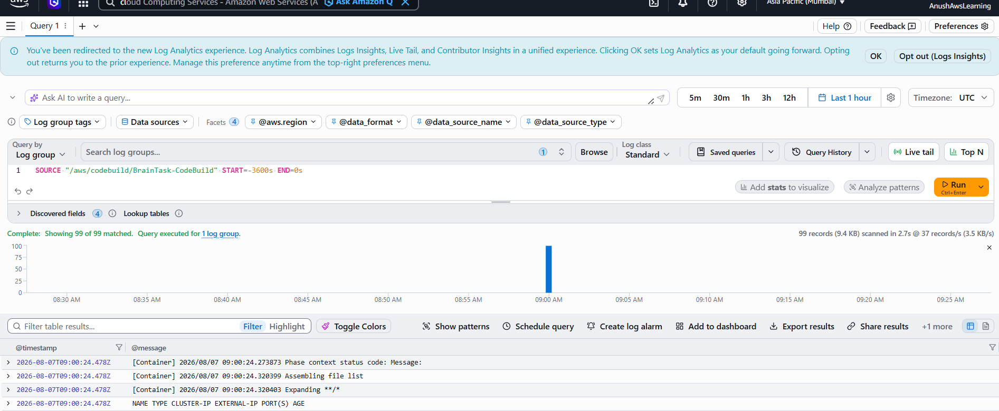

Final Project Architecture
GitHub
│
│ Push
▼
CodePipeline
│
▼
CodeBuild
│
┌───────────┴────────────┐
│ │
▼ ▼
Docker Build ECR Login
│ │
└───────────┬────────────┘
│
▼
Docker Tag
│
▼
Docker Push
│
▼
Amazon ECR
│
│
▼
Update kubeconfig
│
▼
kubectl apply
│
▼
Amazon EKS
│
┌────────┴────────┐
▼ ▼
Pod 1 Pod 2
│ │
└────────┬────────┘
▼
LoadBalancer
│
▼
End User

